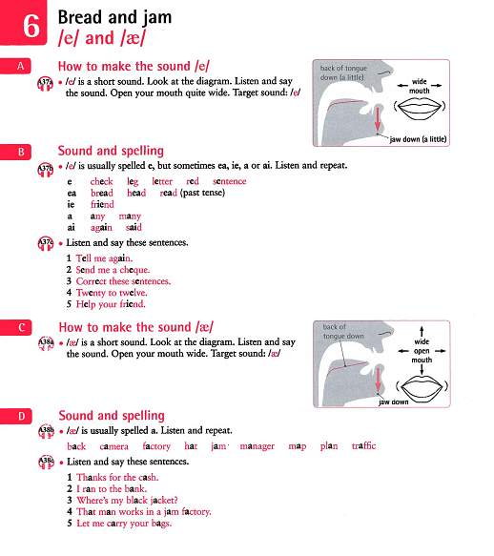

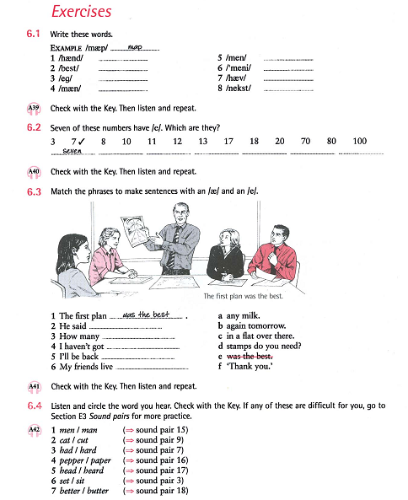
Source: Marks, J. (2007). English Pronunciation in Use Elementary: Self-study and classroom use. Cambridge University Press.

